**MindMatch Game Instructions :**

**In this file I will be gilding you on how to use the game that I created**

1. **At first you will see a welcome message and under that the code will ask you to pick a mode . press 1 for IQ test , press 2 for Math Quiz , and press 3 for English quiz .**

1. **The second step is to pick the number of players if you want to play alone press 1, if you want to challenge a friend press 2 , and if you are 3 or more press 3**

1. **If you are over 3 the code will ask you to type the number of players participating , then enter your names**

1. **Then you will have 6 minutes per person to finish a 10 question test . if you picked the English quiz the code will pick randomly from ( Vocabulary & Word Meaning Questions and Grammar Questions that are in the questions bank ) , if you picked math the code will chose randomly from ( ratio Questions and Mental Math Questions) from the questions bank , but if you picked IQ the code will pick from both of all what I said + general knowledge questions .**

1. **This step is only for the people that picked more than 1 person to play if you picked solo then skip this step . When you finish the 10 questions next person should start solving his/her quiz .**

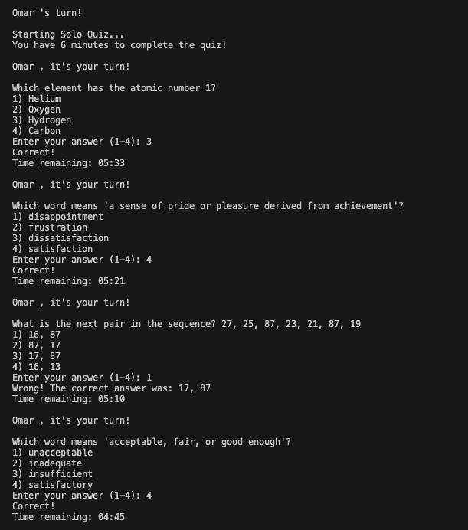

1. **After that the scores will appear then the code will say who is the winner! ! ! ! ! ! ! !**

